Process MeNtOR 3.o

**Uni-SEP**

**Global Statistics Visualization Tool**

Design Document

|  |  |
| --- | --- |
| Version: | 1.0 |
| Print Date: |  |
| Release Date: | 2021/03/24 |
| Release State: |  |
| Approval State: |  |
| Approved by: |  |
| Prepared by: |  |
| Reviewed by: |  |
| Path Name: |  |
| File Name: | GSVT-SDD v1.0.docx |
| Document No: |  |

**Document Change Control**

|  |  |  |  |
| --- | --- | --- | --- |
| **Version** | **Date** | **Authors** | **Summary of Changes** |
| v1.0 | Mar 24 | Ziqin Shang | Architecture and Component Diagram |
| v1.0 | Mar 24 | Yifei Zhang | Use of design pattern and activity plan |
| v1.0 | Mar 24 | Zhen Yang | Introduction, Major Design Decisions and format the document |
| v1.0 | Mar 24 | Yumeng Chen | Class Diagram |

**Document Sign-Off**

|  |  |  |
| --- | --- | --- |
| **Name (Position)** | **Signature** | **Date** |
| Ziqin Shang |  | Mar 24 |
| Zhen Yang |  | Mar 24 |
| Yifei Zhang |  | Mar 24 |
| Yumeng Chen |  | Mar 24 |

**Contents**

**1** **Introduction 4**

1.1 Purpose 4

1.2 Overview 4

1.3 Resources - References 5

**2** **Major Design Decisions 5**

**3** **Architecture 6**

**4** **Detailed Class Diagrams 11**

4.1 UML Class Diagrams 11

**5** **Use of Design Patterns 12**

**6** **Activities Plan 15**

6.1 Project Backlog and Sprint Backlog 15

6.2 Group Meeting Logs 15

**7** **Test Driven Development 17**

# Introduction

## Purpose

This document describes in detail the method of implementing the system < Data Analysis & Retrieval System >. Data analysis and display based on the World Bank's environmental and health data and user choices. Through this system, the user can understand the data more clearly.

## Overview

This project implements the <Data Analysis & Retrieval System> that does the following:

1. A login interface that recognizes combinations of usernames and passwords.
2. Provides users with a choice of countries, years, views, and data analysis methods.
3. Based on the user's choices, extract and analyze the data from the World Bank’s data repository.
4. Present graphs and results.

The SSD document contains the following information:

1. Component Diagram of the system, nested diagrams, explanations on the functionality.
2. Detailed Class Diagram and a textual description of the diagram.
3. Design Patterns for the problems in design.
4. Activities Plan and Group Meeting Logs defines goals and tasks and records progress.
5. Test Driven Form to test the achievement of the system and the problem may occur.

## Resources - References

Word Bank: https://datahelpdesk.worldbank.org/knowledgebase/articles/889392- about-the-indicators-apidocumentation.

Eclipse: http://www.eclipse.org/downloads/index.php

UMLet: https://www.umlet.com/

MS-Visio : https://support.microsoft.com/en-us/office/uml- diagrams-in-visio- ca4e3ae9-d413- 4c94-8a7a-38dac30cbed6?ui=en-us&rs=en-us&ad=us

ObjectAid: https://www.objectaid.com/home

Maven: https://maven.apache.org/

OWL: https://owl.uwo.ca/portal/site/9f39fdce-d5e4-4593-b65b-ae44e70c6813

f7839-c66a-40e5-a9cd-3bd794fa6a76?panel=Main

# Major Design Decisions

The code of the software hasn't been provided too much, but there is a detailed explanation of the type of the parameter and the value returned. More emphasis on the realization of functional ideas and methods. Each call to data and between classes is explained in detail.

Divide the project into several parts ,then analyze the tasks that each class needs to do, and discuss the possible problems in each part. A more detailed explanation of how to solve the problem located at section 5( Use of Design Patterns).

# Architecture

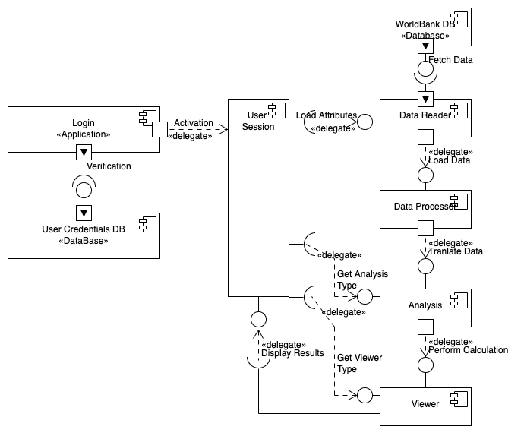

Login:

Functionality: This component is used to log in to the main program. It is the first user interface that’s been displayed to the user, it checks username and password provided by the user and proceeds to the main panel if correct. This object is the dependency in the relation.

|  |  |
| --- | --- |
| Exposed Interfaces | Operation functionality |
| User Credentials Database | Verification: Based on the user input of username and password, verify the authenticity of the user and give feedback back to the login interface. |
| User Session | Activation: If the feedback given from the User Credentials Database is correct, then grant access to the user into the user session. |

User Session:

Functionality: This component shows various features of the software such as the data visualization and the viewers, the user can also choose a range of attributes and graphs to be displayed, it is also the connector of the other essential components.

|  |  |
| --- | --- |
| Exposed Interfaces | Operation functionality |
| Data Reader | Load Attributes: The user session loads all the attributes selected by the user to the data reader, e.g. start and end years, country, and then the data reader will fetch data from the database based on given attributes. |
| Analyzer | Get Analysis Type: The user session loads the analysis type selected by the user to the analyzer, e.g. CO2 emission, PM2.5 air pollution, and then the analyzer will analyze the data based on the given analysis type. |
| Viewer | Get Viewer Type: The user session loads the viewer type desired by the user to the viewer generator, e.g. Pie Chart, Column Chart, and then the viewer generator will generate the graph based on the selected viewer type.  Display Results: After the generation of graph, the viewer will pop the generated graph back to the user session. |

Data Reader:

Functionality: This component is a tool to fetch data from the desired website, it receives information about the wanted data, and then visits the website to collect necessary data to send to the processor class for further use.

|  |  |
| --- | --- |
| Exposed Interfaces | Operation functionality |
| World Bank Database | Fetch Data: The data reader sends requests to the world bank database and fetch data based on given attributes. |
| Data Processor | Load Data: The data reader loads the fetched data to the data processor. |

Data Processor:

Functionality: This component is responsible for translating raw data from the website to a simpler and more precise form that is more efficient to use for analysis.

|  |  |
| --- | --- |
| Exposed Interfaces | Operation functionality |
| Data Reader | Load Data: The data reader loads the fetched data to the data processor. |
| Analyzer | Translate Data: The data processor loads the processed and sanitized data to the analyzer. |

Analyzer:

Functionality: This component performs calculations if needed for the analysis type and integrates the data together for the viewer class to generate graphs.

|  |  |
| --- | --- |
| Exposed Interfaces | Operation functionality |
| Data Processor | Translate Data: The data processor loads the processed and sanitized data to the analyzer. |
| User Session | Get Analysis Type: The user session loads the analysis type selected by the user to the analyzer, e.g. CO2 emission, PM2.5 air pollution, and then the analyzer will analyze the data based on the given analysis type. |
| Viewer | Perform Calculation: The analyzer performs the analysis and calculation based on processed data and given analysis type, then returns the result object to the viewer. |

Viewer:

Functionality: This component is responsible for presenting the data from the result given by the analyzer, it will generate a graph based on the given viewer type and data.

|  |  |
| --- | --- |
| Exposed Interfaces | Operation functionality |
| Analyzer | Perform Calculation: The analyzer performs the analysis and calculation based on processed data and given analysis type, then returns the result object to the viewer. |
| User Session | Get Viewer Type: The user session loads the viewer type desired by the user to the viewer generator, e.g. Pie Chart, Column Chart, and then the viewer generator will generate the graph based on the selected viewer type.  Display Results: After the generation of graph, the viewer will pop the generated graph back to the user session. |

# Detailed Class Diagrams

## UML Class Diagrams

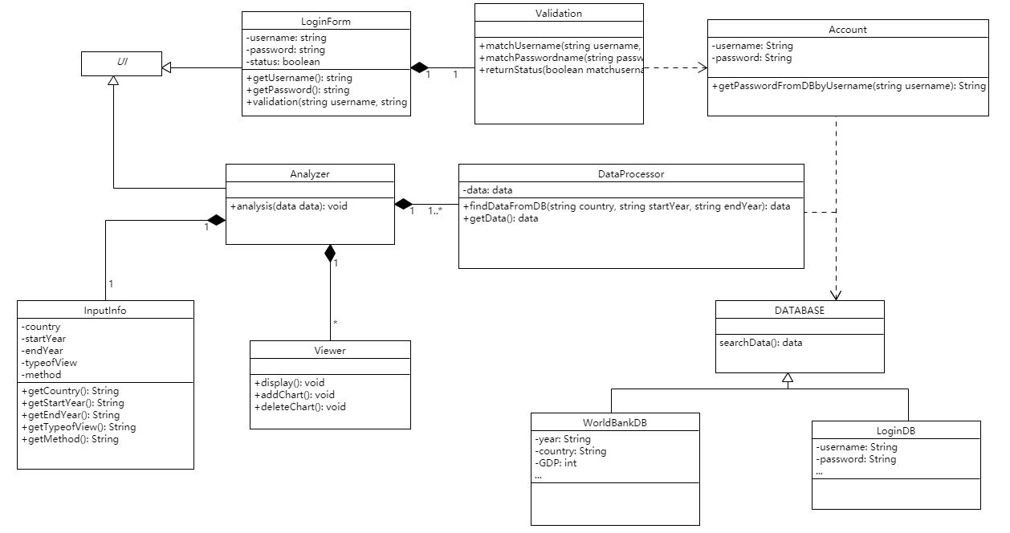

The whole system is composed of two parts. The first part is the login interface. The user name and password entered by the user are obtained through loginform, and then the user name and password stored in the database are called through account, and the information is verified in the verification. If the information is successfully verified, it will enter the data analysis interface, and the analyzer needs to obtain the information selected by the user, such as year, country..., and then dataProcessor obtains the required data by interacting with the database. The analyzer performs data analysis algorithms through the acquired data. And add or delete the chart through the viewer, and display it on the data analysis interface.

# Use of Design Patterns

The following diagram illustrates the use of the **proxy design pattern** in the login process of the program, The Login and Main Window classes are both implementations of UI interface, and the Login class acts as a protection proxy to validate user’s credentials before invoking the Main Window object.

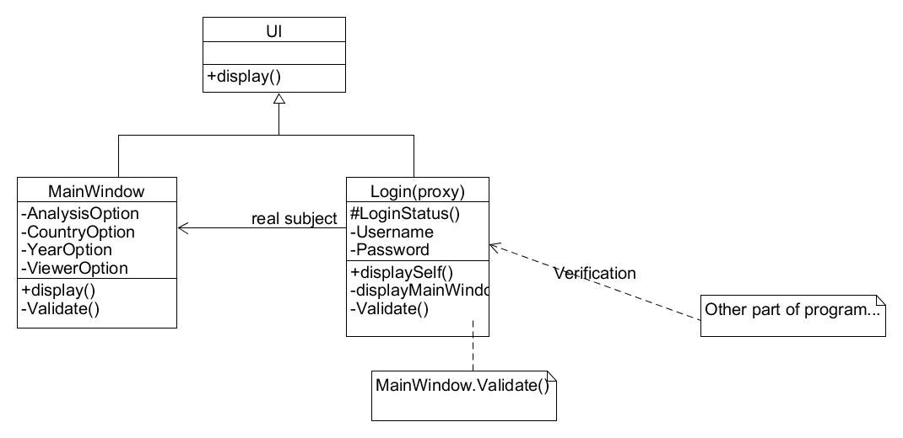

The following diagram illustrates the use of **Façade design pattern** in DataBase Access, to read or write to the databases it will have to be done via this specific class, this will effectively decrease the number of database instances in the program and make it easier to implement the code.

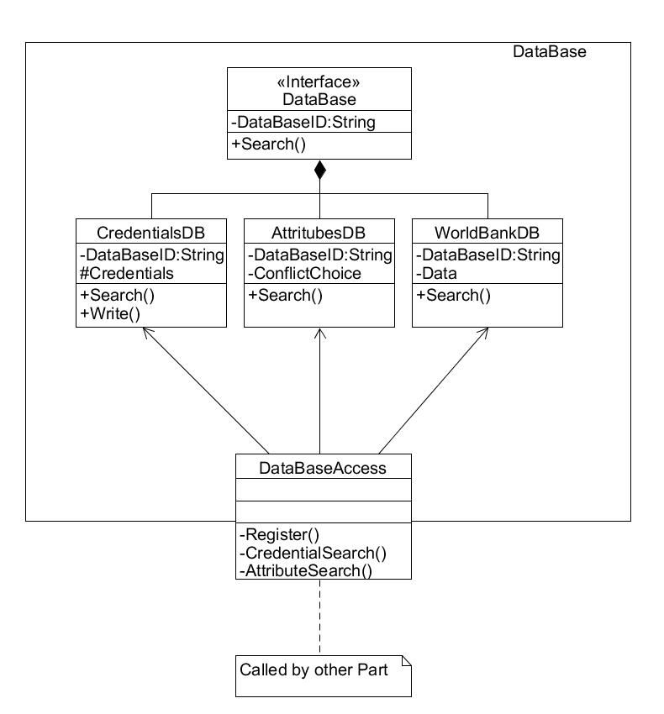

The following diagram illustrates the use of **Factory method design pattern** to create various viewer objects

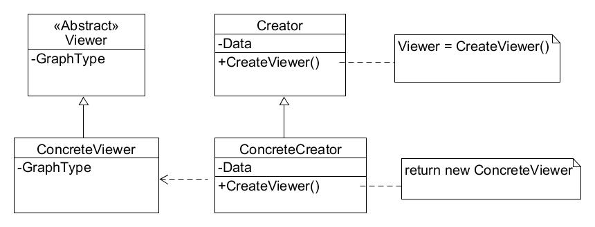

The following diagram illustrates the use of **Chain of Responsibility design pattern**

to process a series request from fetching data to analyze the data for displaying.

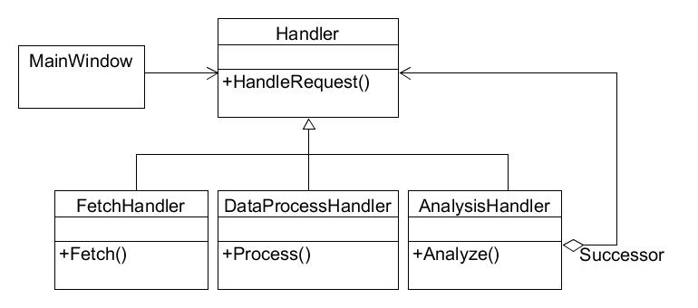

The following diagram illustrates the use of **Strategy design pattern** on various data analysis algorithms which are chosen depending on viewer types chosen by the user.

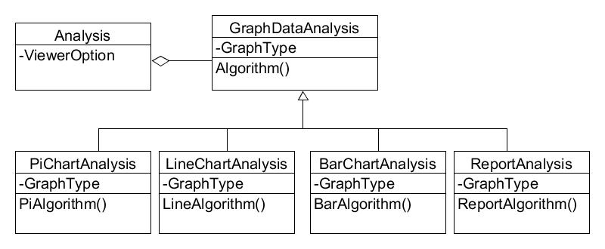

# Activities Plan

## Project Backlog and Sprint Backlog

|  |  |  |  |
| --- | --- | --- | --- |
| Backlog item | Priority | Status | Estimate (hrs) |
| User Interface (Login and Main window) | High | Working | 10 |
| The reader class | High | Working | 10 |
| Data processor class + Analysis class | High | Working | 10 |
| Viewer class | High | Working | 10 |

## Group Meeting Logs

|  |  |  |
| --- | --- | --- |
| **Present Group Members** | **Meeting Date** | **Issues Discussed / Resolved** |
| Yumeng Chen, Zhen Yang, Ziqin Shang,Yifei Zhang | 2021/03/02 | Discussed the distribution of individual tasks, and gathered group ideas on deliverable 3. |
| Yumeng Chen, Zhen Yang, Ziqin Shang,Yifei Zhang | 2021/03/07 | Discussion on each task and the integration process. |
| Yumeng Chen, Zhen Yang, Ziqin Shang,Yifei Zhang | 2021/03/12 | Discussion on each task and the integration process. |
| Yumeng Chen, Zhen Yang, Ziqin Shang,Yifei Zhang | 2021/03/18 | Discussion on each task and the integration process. |
| Yumeng Chen, Zhen Yang, Ziqin Shang,Yifei Zhang | 2021/03/22 | Completion of deliverable 3, merging of individual tasks, and discussion on the implementation of the project for Deliverable 4 |

# 7 Test Driven Development

|  |  |
| --- | --- |
| Test ID | 1 |
| Category | The log-in function of the system implemented to verify through credential DB and the ability to present the user the main window and handle exceptions. |
| Requirements Coverage | UC1-User log in |
| Initial Condition | The database contains some credential pairs enough for the test, the system has been initialized and ready for input. |
| Procedure | 1. The user opens the program.2. The user input usernames and passwords, correct and wrong pairs should be provided to test the full functionality.3. The user logs into the system successfully and the program now presents the main window.4. If the user has entered the wrong username or password, the program should be able to request them again or terminate with a button. |
| Expected Outcome | 1. The credentials matched with the one in the DB and main windows should be presented with the login panel closed after verification.2. If the credentials don’t match, the program should inform the user and prompt for input again. |
| Notes | With some restriction in choosing username and password (e.g., no special characters), the program should be able to handle any combination that is permitted. |

|  |  |
| --- | --- |
| Test ID | 2 |
| Category | The functionality of the main window UI |
| Requirements Coverage | UC2, UC3, UC4, UC5, UC6In this test only the functions of the main window UI specified in these use cases will be the main concern. |
| Initial Condition | The user had successfully logged in, and the main window now initialized. |
| Procedure | 1. Once the main window is presented, test all the functions within the interface (i.e., Ability to select analysis types; countries; years, and to add or remove graph types to be displayed)2. The test should be looking for any formatting, menu, composition errors and mistakes that might occur to the main window. |
| Expected Outcome | The selection and add or remove graph function should work properly, the size of the window and font should be appropriate. |
| Notes | It might be better to prepare some data manually from the world bank website to test some functions such as selection range and the ability to process the data in the raw format. |

|  |  |
| --- | --- |
| Test ID | 3 |
| Category | The evaluation of backstage processes and the cooperation between such functions with the main window UI. |
| Requirements Coverage | UC7-Performing analysis, UC8-Displaying the results |
| Initial Condition | The user had done the selections and chosen the graph types to be displayed, and clicked the recalculate button. |
| Procedure | The list of steps required for this test case (*e.g.*1. The user made selections and clicked the recalculate button.2. The reader class now visits the world bank and fetches the required data that correspond to user’s selection.3. The data is processed into better format and sent for analysis for further process and calculation depending on the user's choice.4. Once the analysis is done, it should be used to generate graphs that the user chose, the graphs are then returned to the main window along with the text-based analysis to be displayed. |
| Expected Outcome | The graphs of chosen analysis types and options should be displayed properly, the program should be ready for another round of analysis. |
| Notes | The test should be performed multiple times with different combinations of selection to ensure the full functionality of the program in all aspects. |